**Proof for email sending project using python:-**

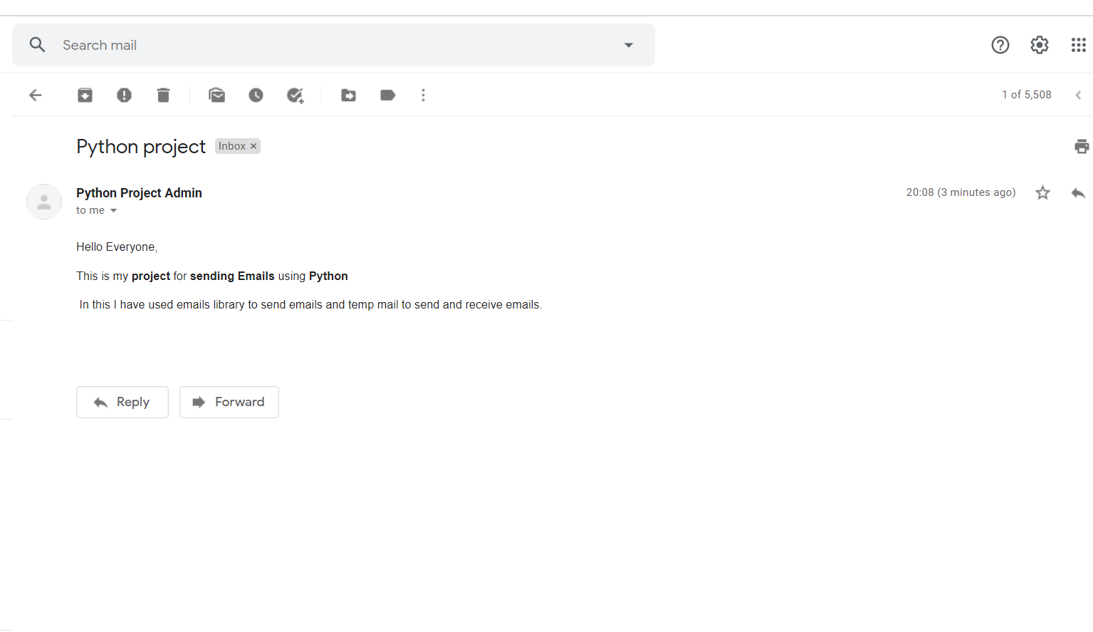

Fig showing received mail for receiver sent by using python

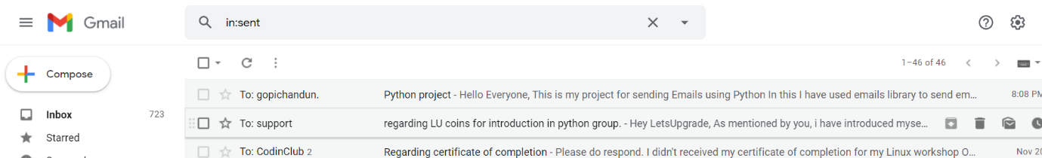

Fig showing mail sent from sender account using python